ATTACHED DOCUMENTS FOR T_CEIPEC INITIALLY FCE PANKSHIN BUT UPGRADED TO FEDERAL UNIVERSITY OF EDUCATION, PANKSHIN

- Letter of Establishment
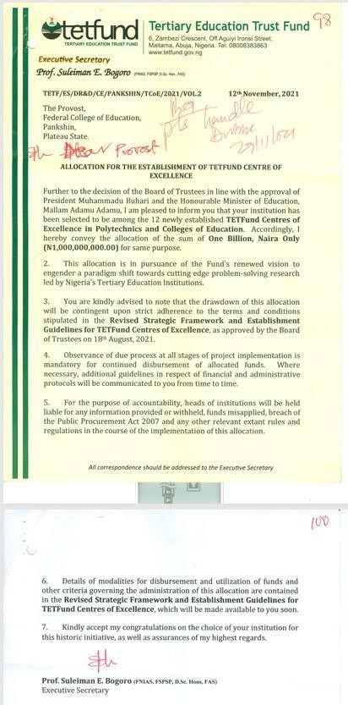

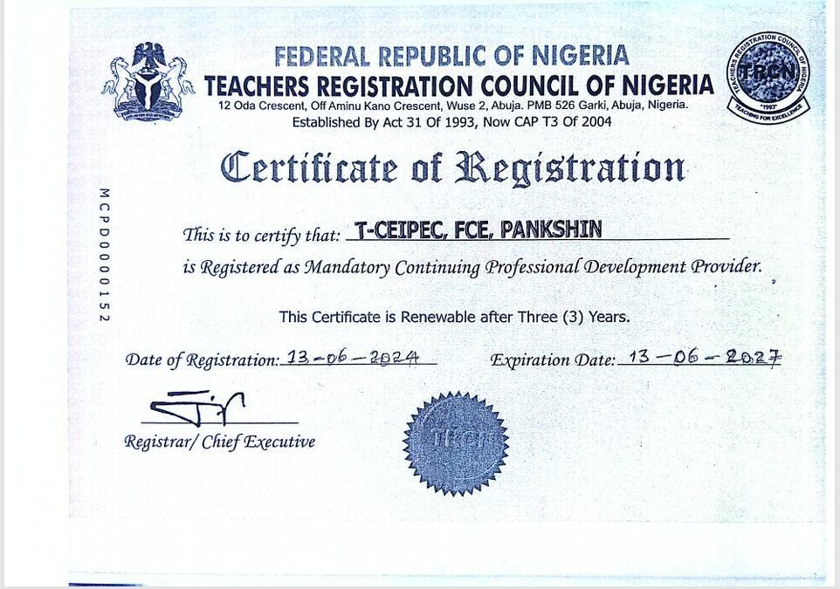
- Letters of Accreditation:
  - American Council of Training and Development
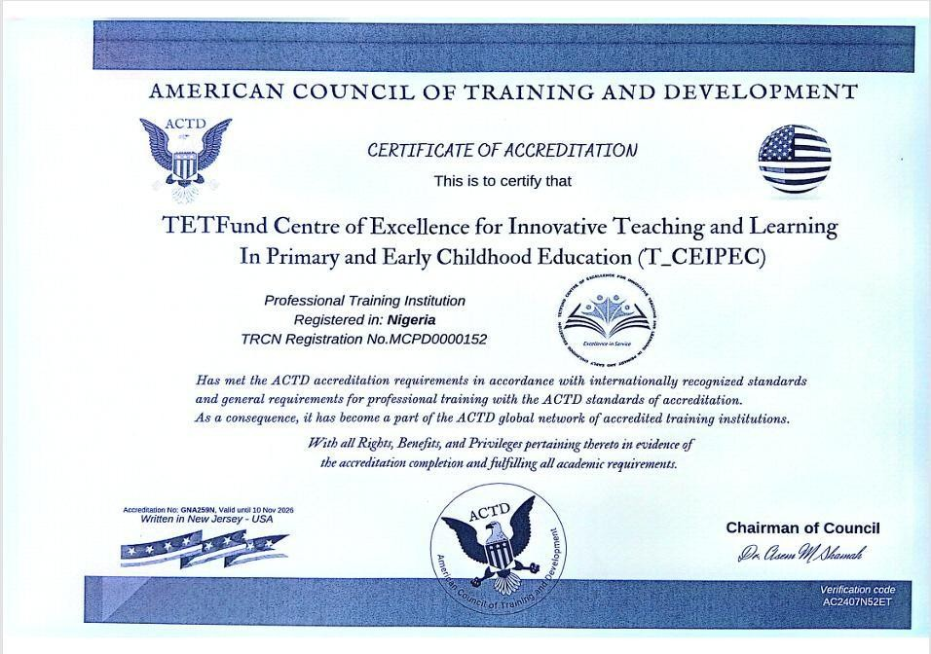
  - Accreditation of the Centre’s MCPD by the TRCN


  - Letter from UBEC
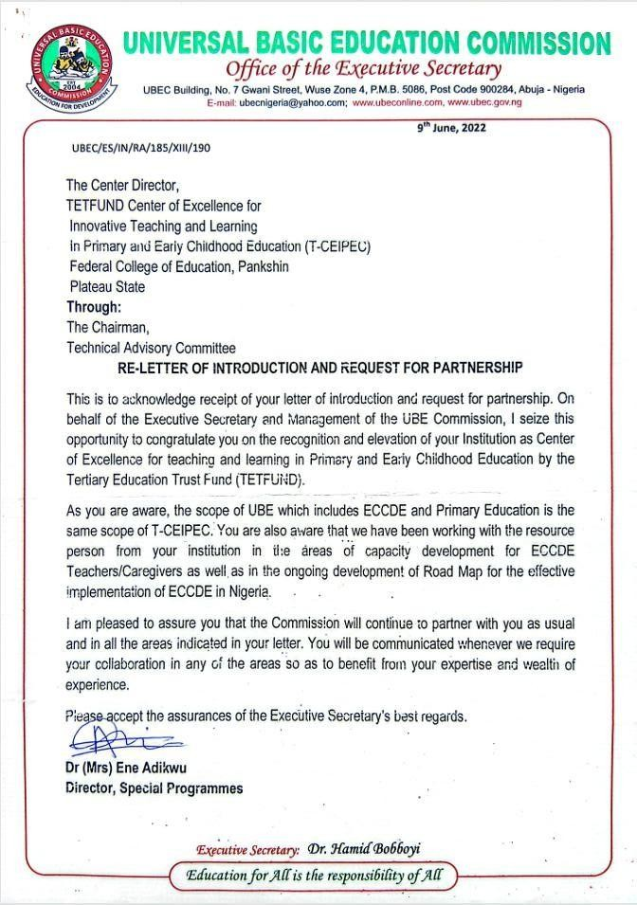

  - Letter of Commendation from the British Council

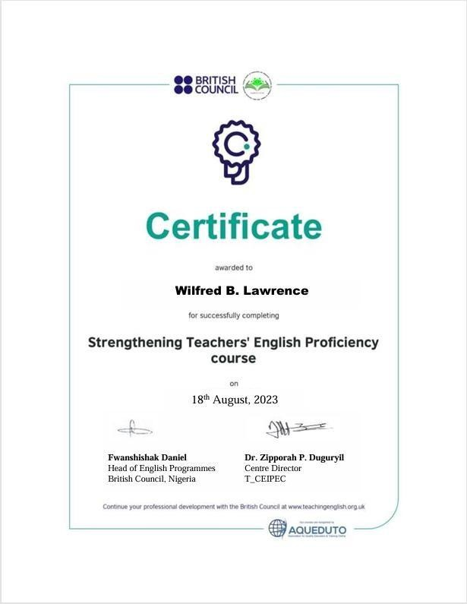
  - Other Attachments; STEP Certification showing collaboration with the British Council

  - MCPD Certification

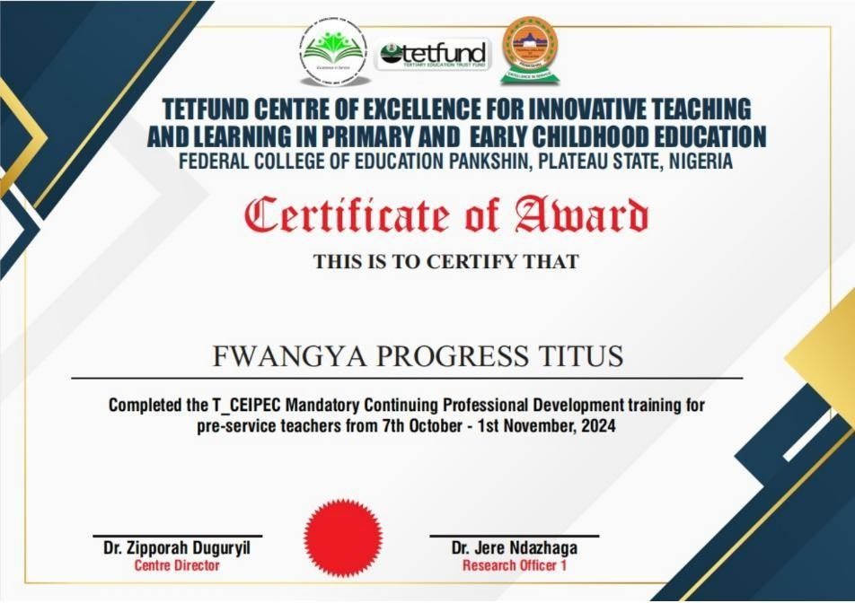

- EVIDENCE OF PROGRAMMES IN THE CENTRE

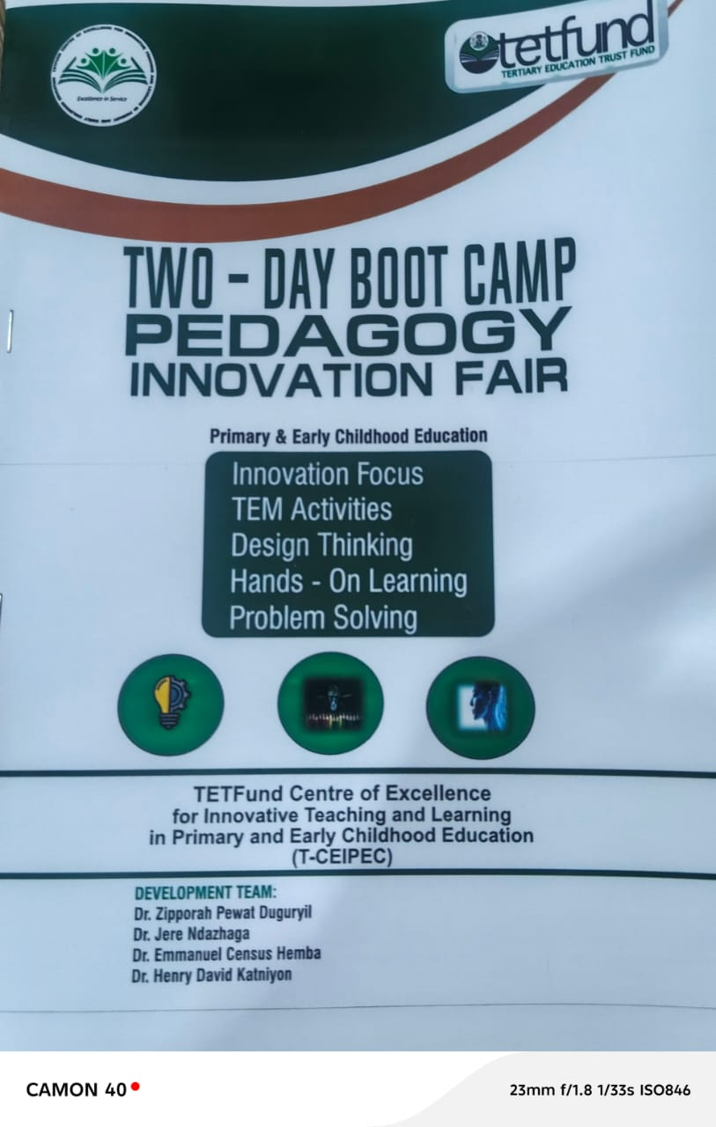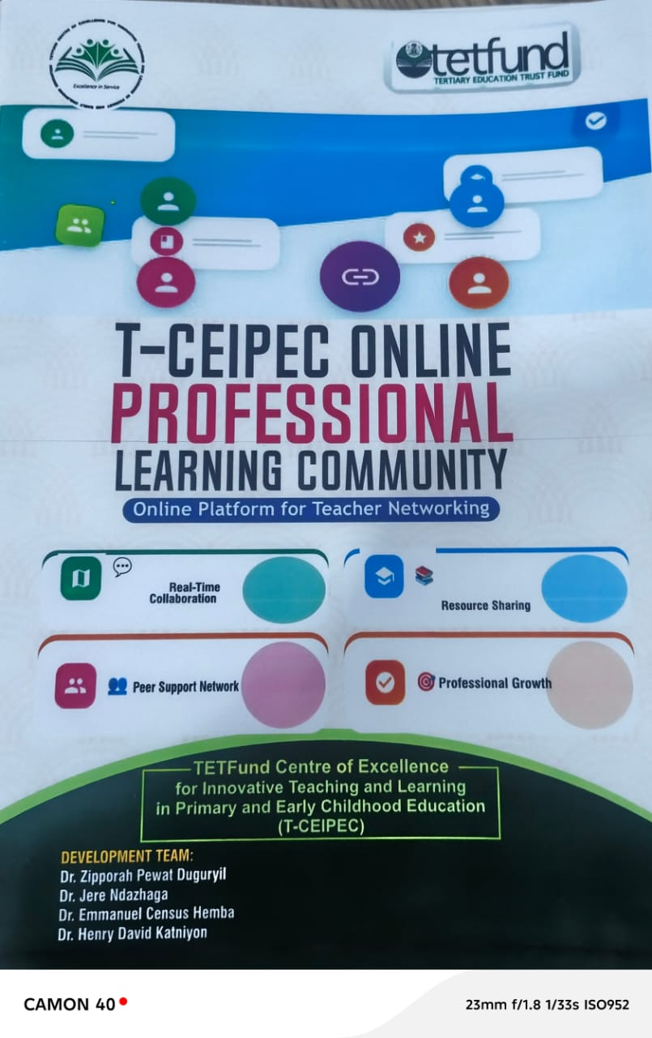

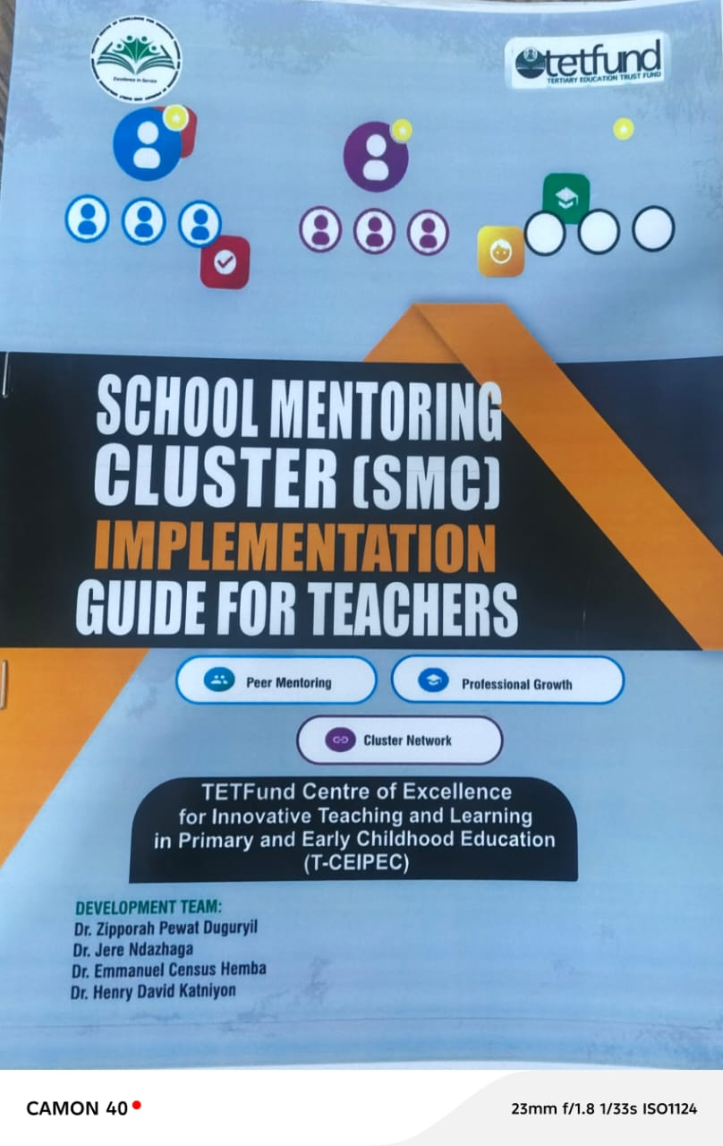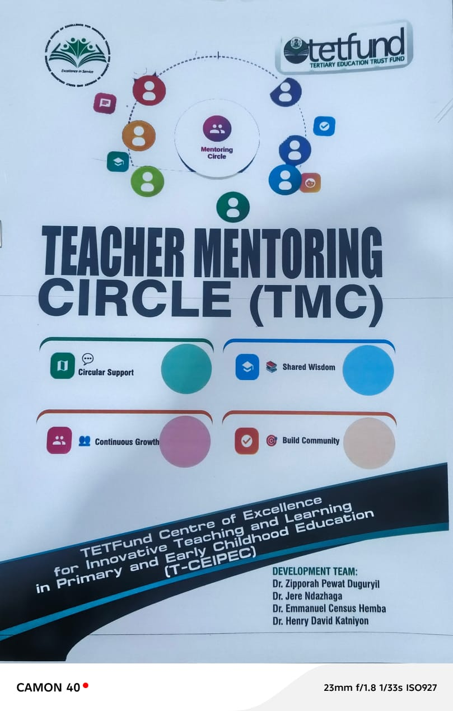

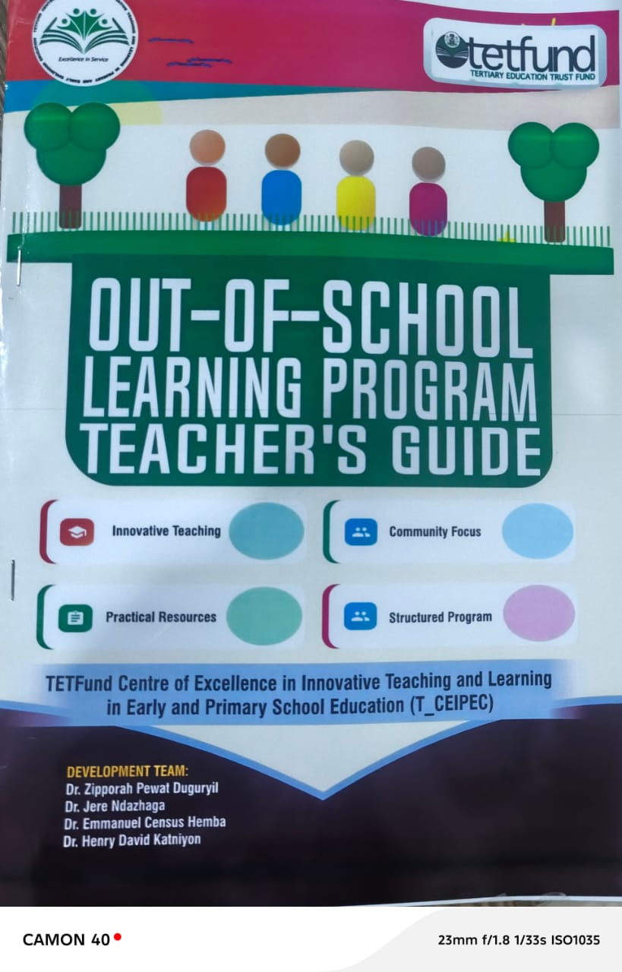
- SAMPLE ATTENDANCE LIST DURING DIFFERENT FORUMS OF THE CENTRE
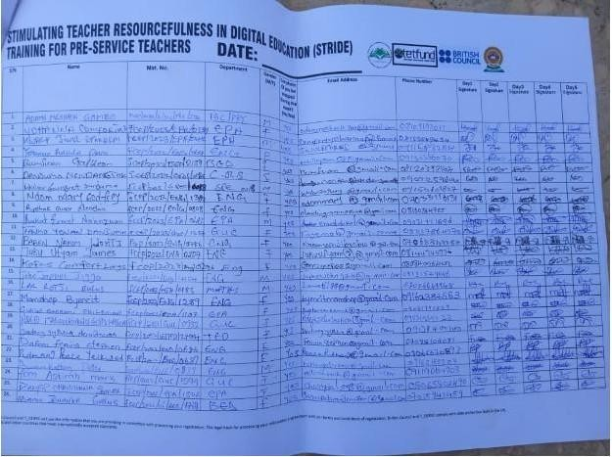
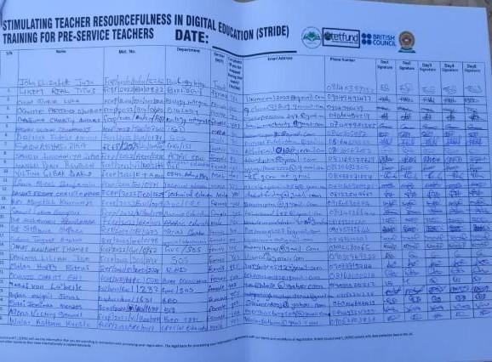
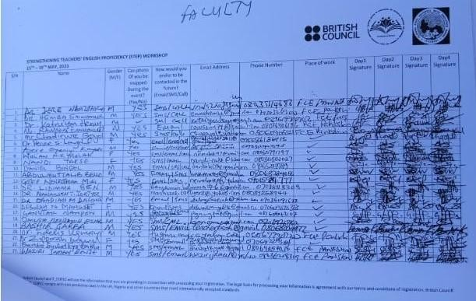

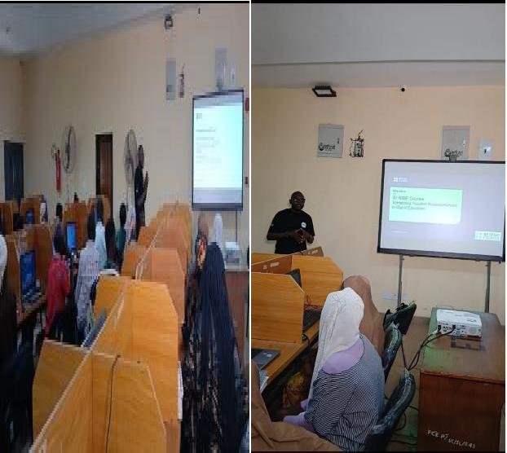
- EVIDENCE OF TRAINING FACILITIES

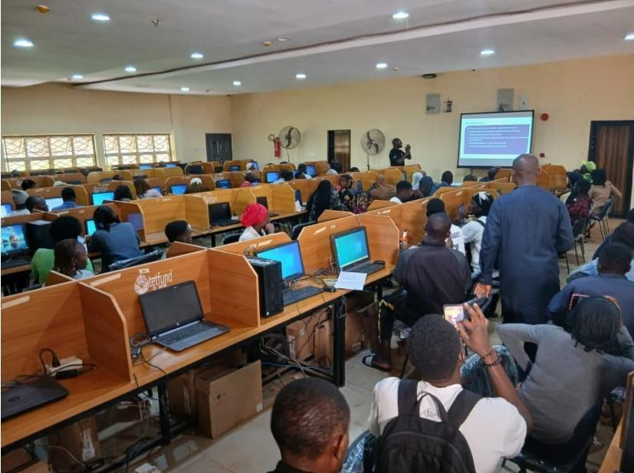



- Letter for Workshop Facilitation
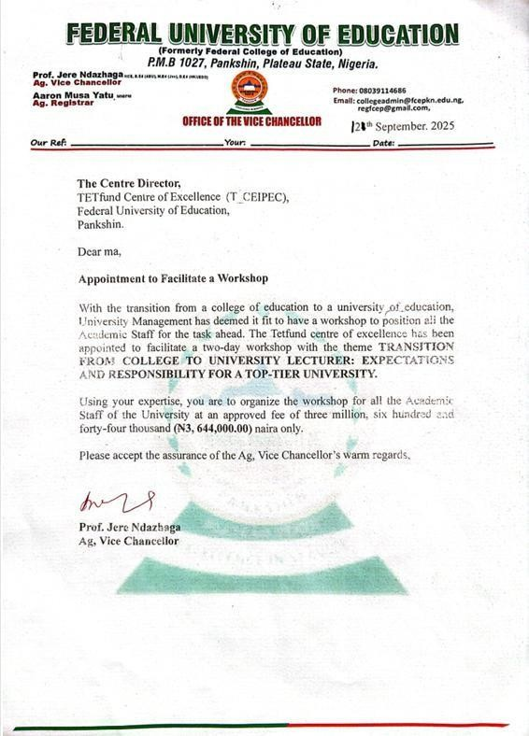

- Letter of Selection as Trainer
